Read Me Muscle Synergy Extraction + DMCI calculation

This code is used to process muscle activity signals and extract muscle synergies with a VAF threshold of 95%. It prints out the muscle synergies constrained into groups of 1-N muscles and its related VAF value.

Inputs
All inputted data feeds in through the ‘create_struct’ function. Each row of this structure correlates to one exercise performed by a participant. See example below:
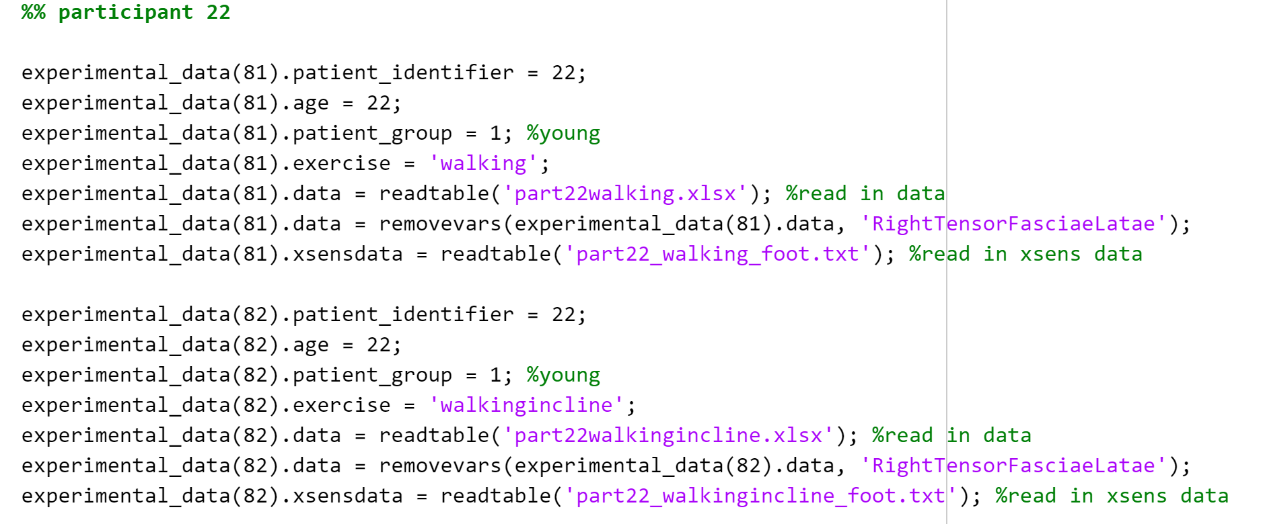
Structure contains several headings:
- Patient_identifier = the identification number given to the participant during the trial (eg. Participant 1, participant 2 etc.)
- Age = age of participant
- Patient_group = allocate ‘1’ for young adult (<50), ‘2’ for old adult (>50).
- Exercise = string variable
- Data = reads in an excel table containing muscle data collected by the BTS FREEEMG sensors
- Xsensdata = reads in a text file containing the XSENS motion capture data for the foot.
Note – the ‘removevars’ function was implemented as it was decided to remove a muscle from the original study. This line may be deleted if it is not applicable to the user’s study.

Running the code
- Run section ‘create_struct’ once to read in all the data required. Ensure the folder containing these excel/text files are added to the same path as the coding files
- Update the ‘expdata_row’ variable with the experimental_data structure row number that correlates to the participant and exercise in question.
- There are two signal processing fuctions – one for the walking data and one for the step data, comment out the one you don’t need.
- Run the second section. The user will see the exp_data row number printed to the screen and then the message ‘muscle data saved’ when the section has completed running.
- Run the function ‘PosturalData_NMFvsPCA_GUI_July2013’. Check the ‘walking data’ checkbox. Click ‘load data’. Click ‘Extract NMF Muscle Synergies’.
- The muscle synergies print into the command window.
  - For DMCI calculation, take note of the 1 synergy value
  - For extracting the number of muscle synergies, take note of number of synergies that is closest to the VAF value you have predefined (80-95%)
- It is recommended that these values are copied into an excel spreadsheet as although they are stored in a variable, the workspace is not saved for each participant/exercise and therefore if MATLAB is close, this information is lost.
Note – The number of muscle synergies to be calculated and printed to the screen has been constrained to 6 for efficiency. If the user wishes to see N muscles synergies, change the iteration on line 183 in ‘PosturalData_NMFvsPCA_GUI_July2013’ to read s=1:nmus.

The function ‘calc_dmci’ has been provided to calculate the dmci for the user. Variable descriptions are explained in the function file.
Inputs:
- Vaf_controlgroup = an array containing the VAF scored of the control group (young adults)
- Vaf_allparticipants = an array containing the VAF score of all participants in the study (young adults and old adults)

